Cheese Pizza OR
Pizza Crunchers with Marinara Sauce
Steamed Broccoli
Garden Salad
Applesauce
Fresh Fruit
Milk
ALL SAINTS’ DAY
NO SCHOOL

Chicken Nuggets with Dinner Roll OR Hot Ham and Cheese Sandwich
Seasoned Potatoes
Baked Beans
Pineapple Tidbits
Frozen Sidekick
Milk
Mandarin Chicken OR Beef
Teriyaki Dippers
Steamed Rice
Steamed Broccoli
Carrots & Celery with Dip
Mandarin Oranges
Fresh Fruit
Milk
Penne Pasta with Meat Sauce OR Chicken Alfredo
Glazed Carrots
Garden Salad
Diced Pears
Frozen Sidekick
Milk
Hot Dog OR Chili Coney
Sweet Potato Puffs
Veggie Boat with Dip
Applesauce
Fresh Fruit
Milk
Grilled Cheese OR
Fish Taco
Tomato Soup
Green Beans
Oyster Crackers
Diced Peaches
Fresh Fruit
Milk
Chicken Patty OR
BBQ Sandwich
Waffle Fries
Carrots & Celery with Dip
Pineapple Tidbits
Fresh Fruit
Milk
Chicken Tenders
Potato Wedges
Garden Salad
Pineapple Tidbits
Fresh Fruit
Milk
Queso Chicken over Rice
OR Beef Enchiladas
Salsa, Sour Cream, Black Beans, Corn
Pineapple Tidbits
Fresh Fruit
Milk
Mini Corn Dogs OR
“Porcupine” Beef Sliders
Macaroni and Cheese
Steamed Broccoli
Carrots with Dip
Diced Peaches
Frozen Sidekick
Milk
Chicken Drumstick with Dinner Roll OR
Turkey Wrap
Mashed Potatoes
Green Beans
Applesauce
Fresh Fruit
Milk
Hamburger/Cheeseburger OR Turkey Sub Sandwich
Potato Wedges
Garden Salad
Diced Pears
Fresh Fruit
Milk
Confetti Pancakes
Scrambled Eggs
Smiley Fries
Veggie Boat with Dip
Baked Apples
Fresh Fruit
Milk
Salisbury Steak OR
Hamburger/Cheeseburger
Mashed Potatoes
Green Beans
Diced Peaches
Fresh Fruit
Milk
NO SCHOOL
HAPPY THANKSGIVING
NO SCHOOL
Cheeseburger OR
Alfredo Chicken Flatbread
Green Beans
Garden Salad
Mandarin Oranges
Fresh Fruit
Milk
Chicken OR Cheese Quesadilla
Salsa, Sour Cream, Black Beans, Corn
Frozen Sidekick
Fresh Fruit
Milk
Roasted Turkey
Mashed Potatoes with Gravy
Stuffing
Sweet Potatoes
Green Beans
Dinner Roll
Applesauce
Pumpkin Pie
Milk

Pizza Crunchers OR
Cheesy Flatbread with Marinara Sauce
Steamed Broccoli
Garden Salad
Diced Peaches
Fresh Fruit
Milk
Prince of Peace Montessori School
News

NO SCHOOL:
Nov. 1 - All Saints’ Day

Nov. 21, 22, 23 – Thanksgiving break

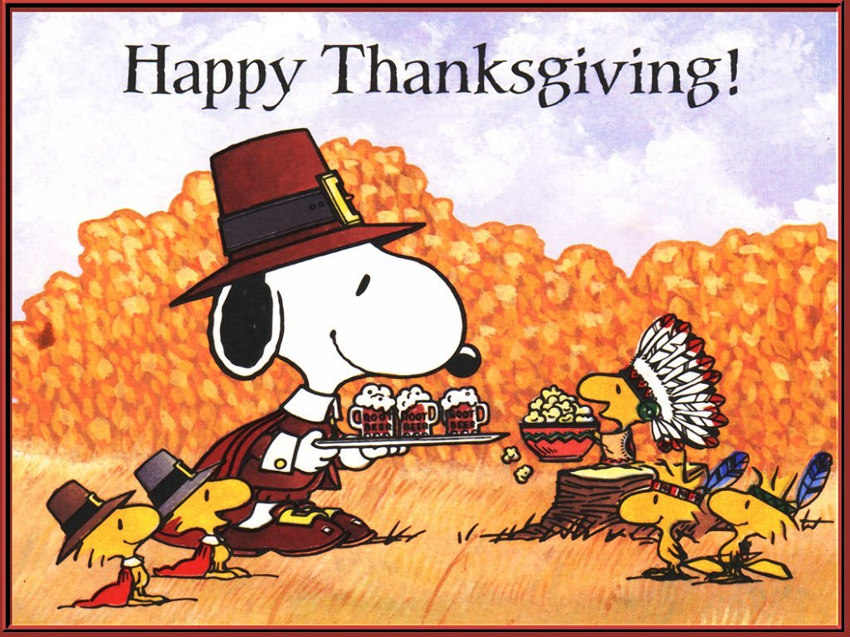

Menu subject to availability

Enter Other Information Here

