Chicken Nuggets with Roll
OR Hot Ham & Cheese
Emoticon Potatoes
Baked Beans
Pineapple Tidbits
Frozen Sidekick
Milk
Queso Chicken over Rice
OR Beef Enchiladas
Salsa, Sour Cream
Black Beans
Corn
Pineapple Tidbits
Fresh Fruit
Milk
Mini Corn Dogs OR
“Porcupine” Beef Sliders
Macaroni and Cheese
Steamed Broccoli
Carrots with Dip
Diced Peaches
Fresh Fruit
Milk
Confetti Pancakes
Scrambled Eggs
Emoticon Potatoes
Veggie Boat with Dip
Baked Apples
Fresh Fruit
Milk
Hamburger/Cheeseburger
OR Turkey Sub Sandwich
Potato Wedges
Garden Salad
Diced Pears
Fresh Fruit
Milk
NO SCHOOL
Mandarin Chicken OR
Beef Teriyaki Dippers
Steamed Broccoli
Carrots & Celery with Dip
Steamed Rice
Mandarin Oranges
Fresh Fruit
Milk
Penne Pasta with Meat Sauce OR Chicken Alfredo
Glazed Carrots
Garden Salad
Diced Pears
Fresh Fruit
Milk
Hot Dog or Chili Coney
Sweet Potato Puffs
Veggie Boat with Dip
Applesauce
Fresh Fruit
Milk
Grilled Cheese OR
Fish Taco
Tomato Soup
Garden Salad
Diced Peaches
Fresh Fruit
Milk
Chicken Patty OR
BBQ Sandwich
Waffle Fries
Carrots & Celery with Dip
Pineapple Tidbits
Fresh Fruit
Milk
Chicken Tenders
Potato Wedges
Garden Salad
Pineapple Tidbits
Fresh Fruit
Milk
Queso Chicken over Rice
OR Beef Enchiladas
Salsa, Sour Cream
Black Beans
Corn
Pineapple Tidbits
Fresh Fruit
Milk
Mini Corn Dogs OR
“Porcupine” Beef Sliders
Macaroni and Cheese
Steamed Broccoli
Carrots with Dip
Diced Peaches
Fresh Fruit
Milk

Confetti Pancakes
Scrambled Eggs
Emoticon Potatoes
Veggie Boat with Dip
Baked Apples
Fresh Fruit
Milk
Salisbury Steak OR
Hamburger/Cheeseburger
Mashed Potatoes
Green Beans
Diced Peaches
Fresh Fruit
Milk
3 or 4 Way Chili Spaghetti
Glazed Carrots
Garden Salad
Diced Pears
Frozen Sidekick
Oyster Crackers
Milk
Beef Nachos OR
Beef Soft Taco
Salsa, Sour Cream
Refried Beans, Corn
Applesauce
Fresh Fruit
Milk
Cheese OR Pepperoni
Pizza
Steamed Broccoli
Garden Salad
Mandarin Oranges
Fresh Fruit
Milk
Cheesy Flatbread with Marinara Sauce OR
Alfredo Flatbread
Green Beans
Garden Salad
Mandarin Oranges
Frozen Sidekick
Milk
Chicken OR Chicken Quesadilla
Salsa, Sour Cream
Black Beans
Corn
Diced Pears
Fresh Fruit
Milk
French Toast Bites OR
Confetti Pancakes
Sausage
Veggie Boat with Dip
Baked Apples
Fresh Fruit
Milk
Pizza Crunchers OR
Chicken Patty
Marinara Sauces
Steamed Broccoli
Garden Salad
Diced Peaches
Fresh Fruit
Milk

PRINCE OF PEACE MONTESSORI SCHOOL
News

No School – October 5

Menu subject to availability.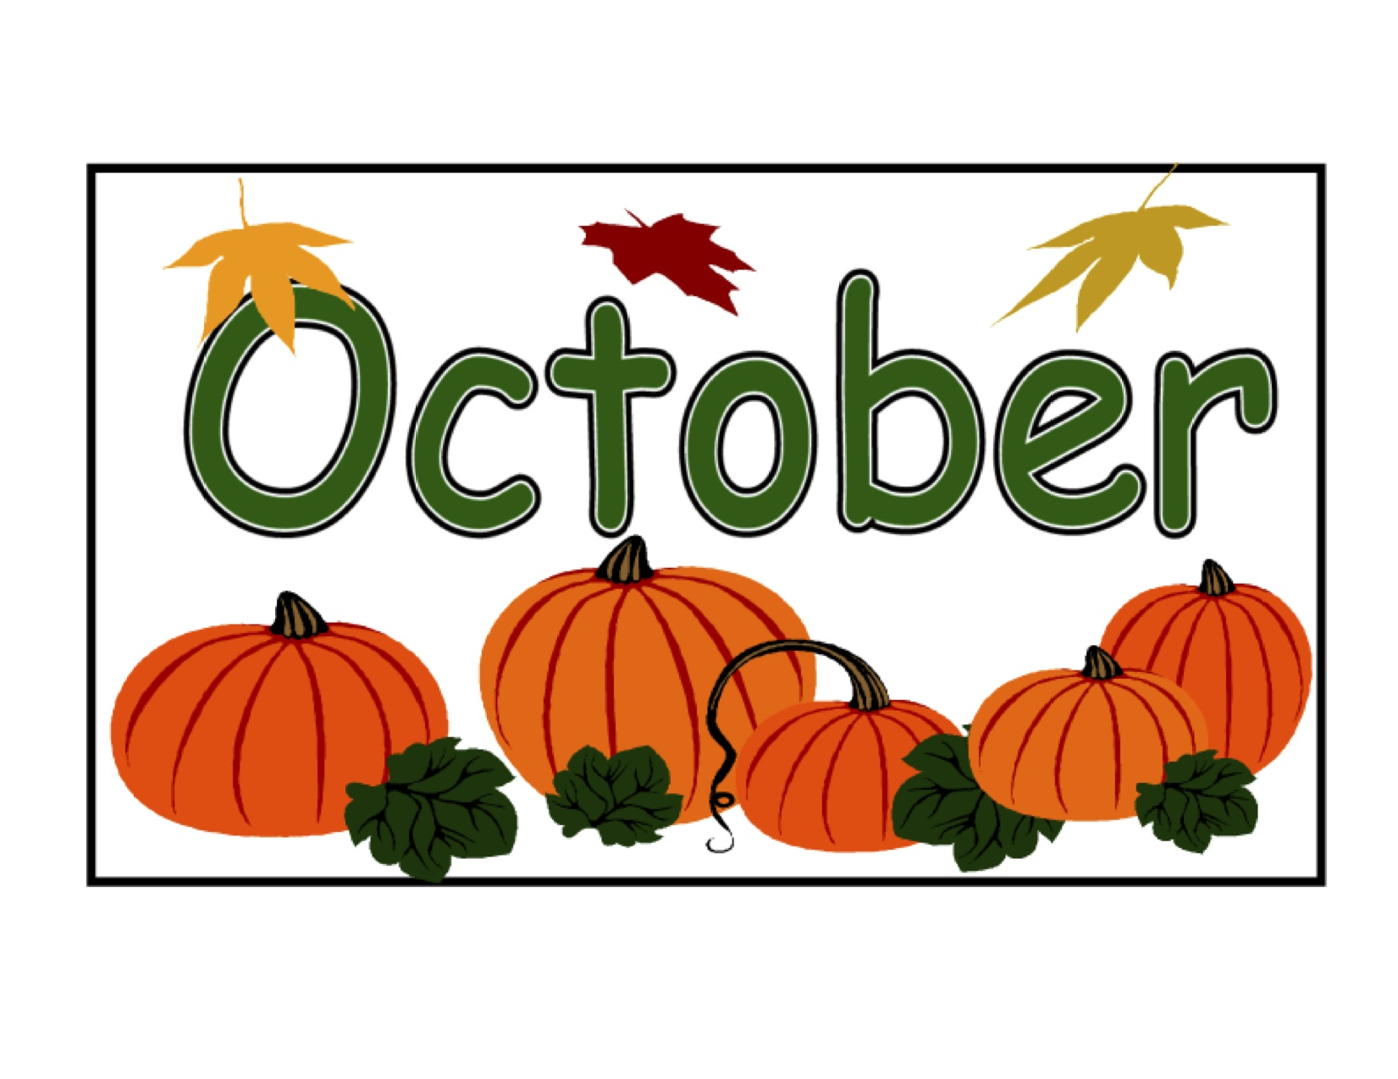
Enter Other Information Here

